**Introduction**

In this lab, we created a hazardous flip-flop circuit and verified it.

**Preliminary Work**

Given a specific circuit diagram, we were required to build a circuit diagram according to the limited chips we have.

First we created a state table:

|  |  |  |  |
| --- | --- | --- | --- |
| **X** | **Q** | **Q’** | **D** |
| 0 | 0 | 1 | 0 |
| 0 | 1 | 0 | 1 |
| 1 | 0 | 1 | 1 |
| 1 | 1 | 0 | 0 |

Using a K-map I derived the expression:

D = X’Q + XQ’

From the table I derived the state diagram:

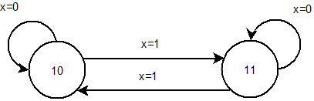

From the K-map I forged a circuit diagram.

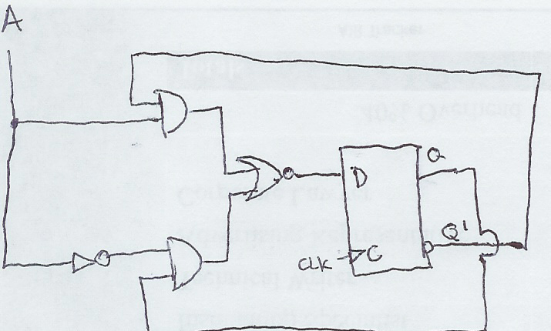

**Wire List (with hazard)**

Finally we created the wire list for the new circuit.

U1 = SN74LS04 (NOT)

U2 = SN74LS02 (NOR)

U3 = SN74LS08 (AND)

U4 = SN74LS74

VCC = Voltage

GND = Ground

VCC 🡪 U1-14, U2-14, U3-14, U4-14

GND 🡪 U1-7, U2-7, U3-7, U4-7

A 🡪S1 🡪 U3-1, U2-13

U4-6 🡪 U3-2

U3-3 (X1) 🡪 U2-2

U1-12 (X2) 🡪 U3-13

U4-5 🡪 U3-12

U3-11(X3) 🡪 U2-3

U2-1(X4) 🡪 U4-2(D)

U4-2(D) 🡪 LED

U4-3(CLK) 🡪 LED

**Lab Work:**

Wire and test the circuit.

**Results**

I wired the circuit, but not test it. (I was absent)

**Observations and Conclusions:**

The point of the lab was to demonstrate how a flip-flop works. When A is 0, D changes on and off. When as A is 1, D stays the same. The flip-flop is able to hold and change states.